The Weather App

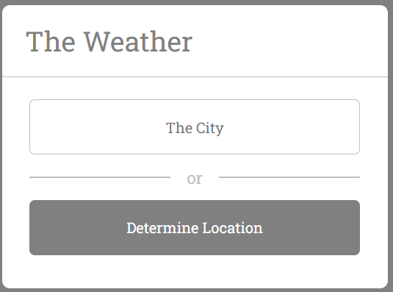

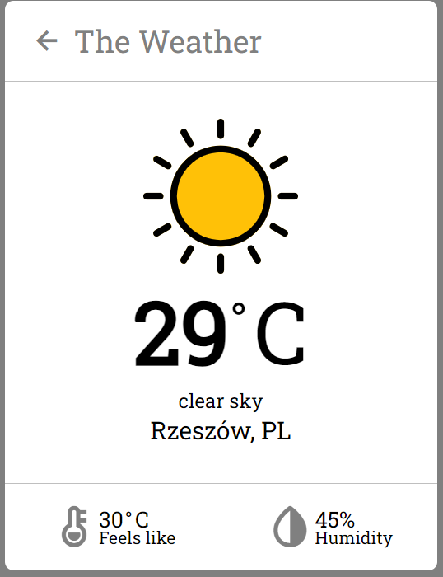

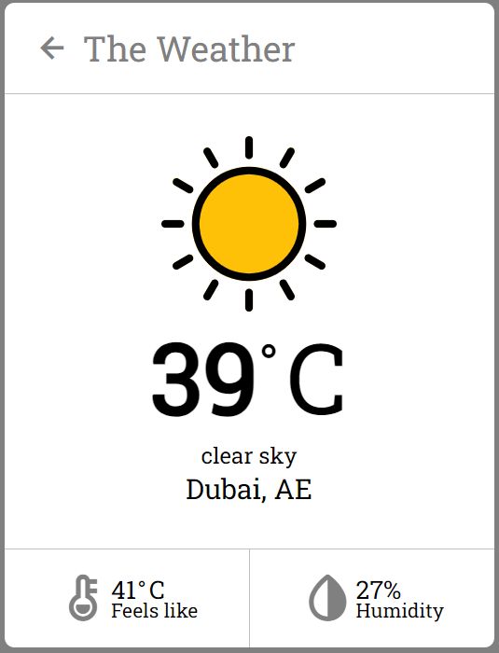

**HTML**

**Head Section**: Links to external resources such as stylesheets and fonts.

**Body Section**: Contains a wrapper that holds all the main elements, including:

- A header with a back arrow icon and the title "The Weather".

- An input section for entering a city name or using geolocation to determine the location.

- A weather information section that displays the weather icon, temperature, description, location, feels-like temperature, and humidity.

**CSS**

**Global Styles**: Reset margins and padding, set a default font, and ensure consistent box-sizing.

**Body Styles**: Center the content vertically and horizontally, and set a background color.

**Wrapper Styles**: Define the dimensions, background color, and border radius of the main container.

**Header and Input Section Styles**: Style the header, input field, button, and informational text, including error and loading states.

**Weather Information Section Styles**: Style the elements that display weather data, such as the temperature, weather icon, location, and additional weather details.

**JavaScript**

**Event Listeners**: Respond to user interactions, such as pressing the "Enter" key to submit a city name or clicking a button to use geolocation.

**Geolocation Handling**: Get the user's current location coordinates and build an API request URL based on these coordinates.

**API Requests**: Fetch weather data from the OpenWeatherMap API using the city name or coordinates.

**Data Processing**: Handle the API response to display weather details or show error messages if the city is not found or if there is a geolocation error.

**UI Updates**: Dynamically update the DOM to show or hide sections and display the fetched weather data.

**How It Works Together**

**1. User Input and Interaction**:

- The user inputs a city name or clicks a button to use geolocation.

- JavaScript listens for these interactions and triggers appropriate functions to fetch weather data.

**2. Fetching and Displaying Data**:

- JavaScript constructs the API URL and fetches data from the OpenWeatherMap API.

- Upon receiving the data, JavaScript updates the HTML to display the weather information.

- The CSS ensures the updated content is styled correctly and is visually appealing.

**3. Error Handling**:

- If there's an error (e.g., city not found or geolocation fails), JavaScript updates the HTML to show an error message.

- The CSS styles the error messages appropriately to inform the user.

Made By:

Khalid Katamato W68907

Ziya Atay W69041